GLAC

https://www.nps.gov/glac/planyourvisit/images/bcbanner.jpg

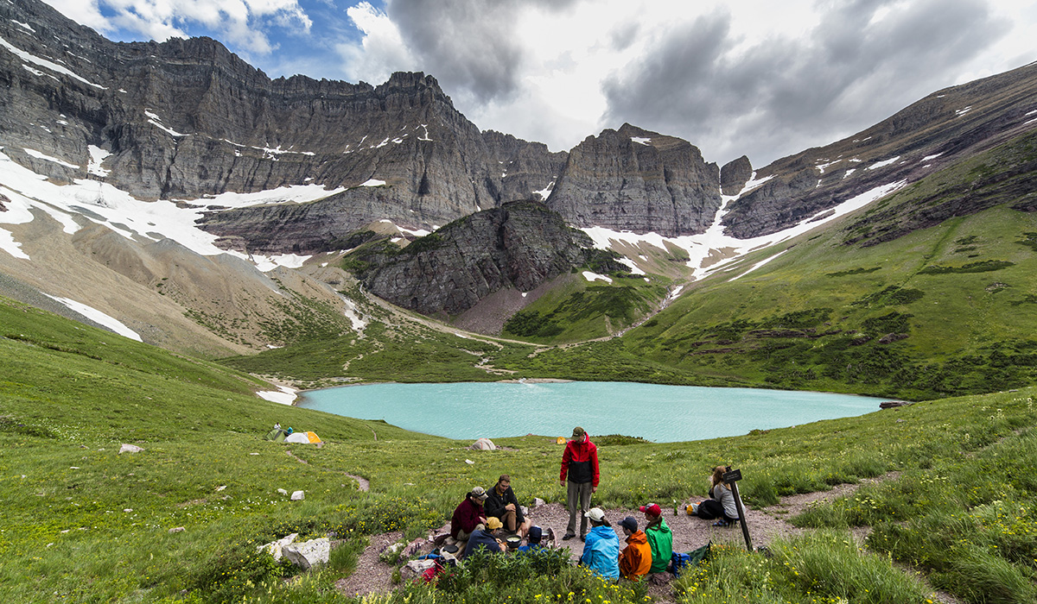

ZION

https://www.nps.gov/zion/planyourvisit/images/Subway.jpeg

